ZF Technology and Policy of Electrical Energy Storage

Lecture 1:
3 Reasons to look at energy storage:
- Still 1.1bn people lack access to electricity; strong correlation of electrification rate and poverty rate
Renewables with batteries can help (Micro-Grids with battery storage cheaper than diesel-generator)
- Oil production and reserves won’t be able to meet demand indefinitely and will become costly
also plays major role in geopolitics
Road transport is and will be major consumer of oil alternative solution needed to reduce dependency
- Climate Change
electricity: highest emissions (beside industry) and highest emission growth rates
Most renewables are intermittent need storage solution to balance electricity shortage/over-production

Different energy storage applications with different specifications
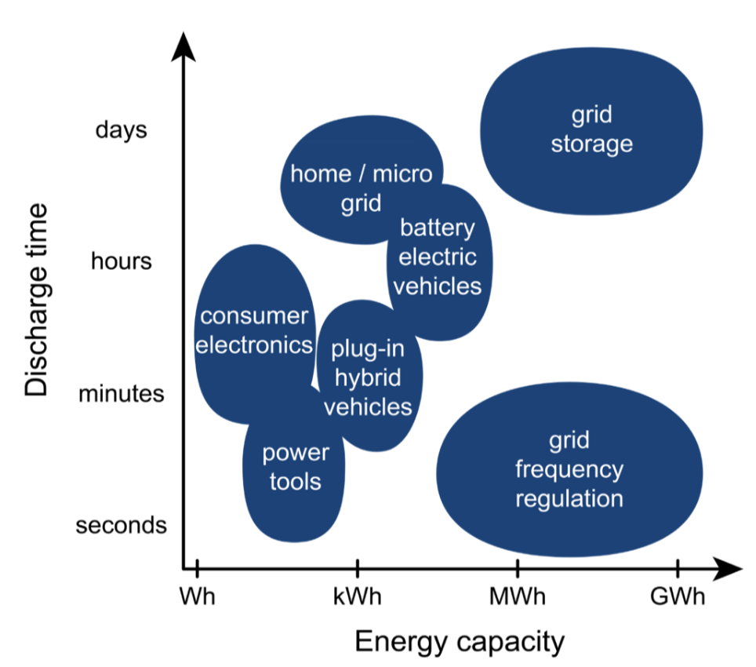 | Most important Variable storage application  - Charging/Discharging time  - Energy capacity  - Cycle Frequency  - power, density, weight and size, price, heat development, …

Different Energy storage Technologies
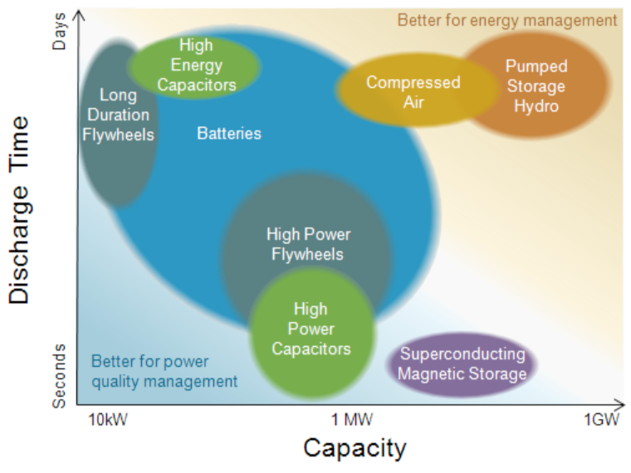 | Pumped hydro still dominating global installed capacity (MW), followed by electrochemical (mostly lithium based) and thermal  Cost of Storing electricity still high  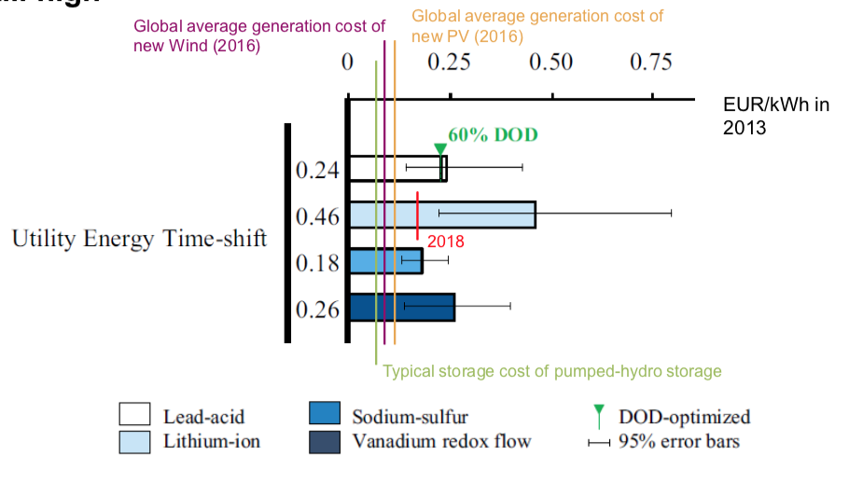

The future is bright:  3 strong trends driving case of energy storage  - Rise of intermittent renewable power generation  - Rise of electric mobility  - Falling costs of storage technologies due to innovation and scale  As consequence, industry’s expectations for energy storage are high | The present however is grey:  - Current systemic demand in most mainland electricity grids is limited for energy storage  - Economic viability of energy storage serving one application is NOT easy to achieve in most countries  - Electric mobility still depends on policy support  - Several bankruptcies of leading energy storage companies
Summary of Lecture:
- Electric energy storage (EES) will play important role in a low-carbon, highly electrified future in different applications. At the moment, the situation is still dependent on policies.
- Batteries (in particular Li-ion) are relatively flexible EES solution
- Further innovation is needed in order to improve performance and reduce cost of new EES technologies

Lecture 2:
Political System

Role of the State in the economy?

When is policy intervention justified?
Neo-classical (mainstream) economics
Policy intervention is justified when Market failures exists:
- Externalities  - Market power  - Monopoly | - Property Rights  - Information failure

Policy is about ensuring fair market transactions

Evolutionary economics
Policy intervention in order to redirect social and technological development:
- Markets are good for near-term optimization, only (tech space, time)
- Externalities
- System failures (coordination issues)
Policy is about shaping new systems and markets

Energy system specifics:
- Long time horizons
- Large investments
- Heterogeneity and strong externalities: underlying factors of complexity and uncertainty
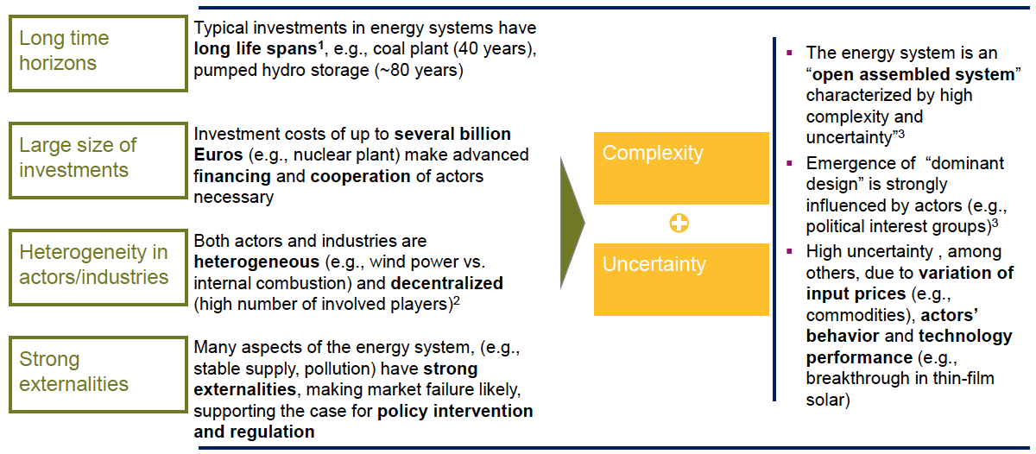

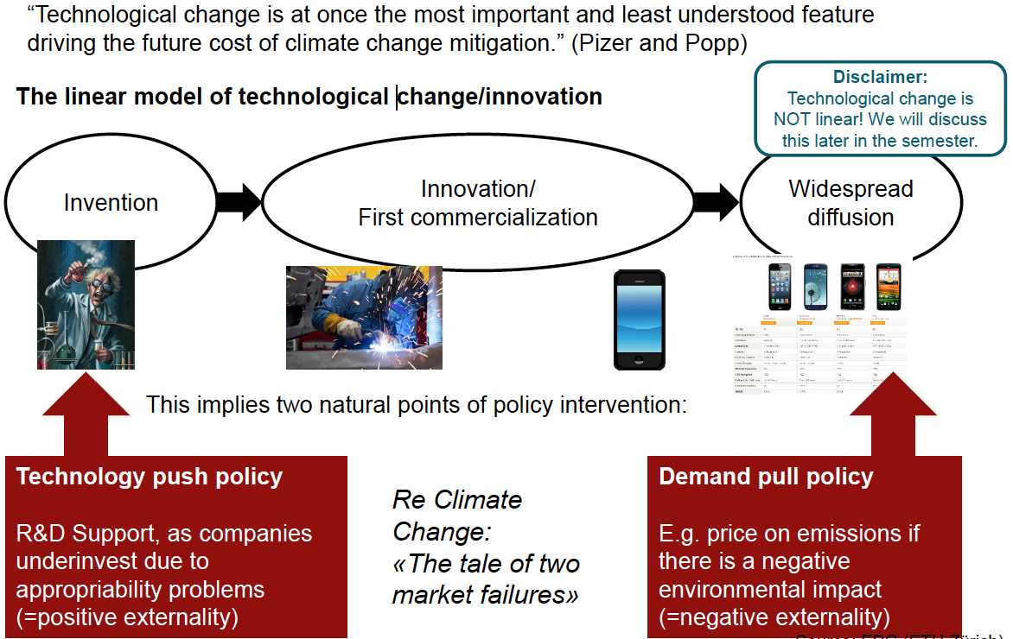
Complexities in policy and Politics:
- Many policy instruments come at a significant cost
- Public funds are limited unless tax revenues are raised can have detrimental effects on economy
- Competition for funds between different actors within political arena (different ministries)
- Allocation of funds is outcome of political process
- Ministry of finance is always central and powerful (have the money and decides over it)
One option: tap into private finance, use public funds to leverage private funds

Policies related to Energy
- Health Policy: Health care goals, Quality of life
- Energy Policy: Supply security, Cost of energy
- Security Policy: Protection of state and citizens against nation al crises, Energy independence
- Industrial Policy: Welfare maximization, Development and growth of competitive industries and avoidance of monopolies
- Monetary Policy: Control of money supply, Targeting an inflation or interest rate
- Environmental Policy: Preservation of biophysical environment, Climate change mitigation

Policy Cycle: Agenda setting Policy formation legitimation implementation evaluation policy maintenance agenda setting

Learning Objectives:  - Get introduced to public policy terminology  - Understand different intervention rationales (steady state vs transformational) and types  - Scratch the surface of some complexities involved in policy design, particularly for storage technologies | Three take-home messages  1. Policy intervention can have different rationales (steady state vs transitions)  2. Policy is instrumental for both steady state and transitions, especially if externalities are present and infrastructure sectors are concerned  3. Policy-making is an ever ongoing business that is shaped by financial constraints, politics, and polity  4. The multi-purpose character of storage provides for many demand-pull policy interventions

Lecture 3:

Definition Battery: Device that converts chemical energy contained in its active materials into electrical energy by means of an electrochemical oxidation-reduction (redox) reaction. A Battery is a set of cells connected in parallel or series to provide the required operating voltage and current.

Types of Lithium Ion Cells: Cylindrical, Pouch (Nokia battery), Prismatic

Definitions:
Anode: Electrode where electrons leave the active material (through the external circuit) Graphite/LTO (Lithium tetanate oxide)
Cathode: Electrode where electrons enter the material (through the external circuit)
LCO, NMC, NCA, LFP
Battery Slang:
Positive Electrode is called the Cathode
Negative Electrode is called the Anode
Charge | Discharge

Cell Reactions

- Lithium content of materials changes during cycling
- With increasing Li content, material potentials move towards the Li potential (i.e. become smaller).
- Relation between how much Li in active material and electrode potential

Cell Voltage = Voltage of positive electrode – Voltage of negative electrode $E_{cell}=E_{+}-E_{-}$
Cell Voltage = V_{cathode} – V_{anode}
Cell voltage is the difference between anode and cathode potential

Cell voltage changes with State-Of-Charge (SOC)
Kinetic processes differ between charge and discharge, Hysteresis is typically dependent on charging rate

Theoretical Gravimetric Capacities of Active Materials
Faraday Constant (F)
1F = 96’485.32 C/mol = 26.8 Ah/mol $\frac{n∙F}{MW}=\frac{mAh}{g}$ MW: molar weight

Tradeoff: Graphite is light better than LTO for applications where mass is important but doesn’t bring a gain when size not mass is not important (stationary power grid applications)

Big difference between theoretical loading and actual loading since electrode not all active material:
Theoretical gravimetric capacity of graphite: 372 mAh/g
Theoretical volumetric capcity of graphite: 818 mAh/cm³ (density is 2.2 g/cm²)
Loading of 50µm thick electrode = 2.8 mAh/cm² (only 70% is graphite)

Less than 50% of Cell Mass and Volume is active Material (rest is additives, binder, porosity electrolyte, separator packaging, current collectors)

Kinetics in a Cell

Electronic  • Current collector contact resistance to electrode  • Electronic resistance of porous electrode (electronic into / out of active materials, through active material, carbon black/binder network)  Ionic  • Lithium diffusion in electrolyte  • Solid state diffusion (ions active material)  • Surface kinetics (i.e. lithium into/ out of material)  More energy out of thicker cells, need thin electrodes to get energy out fast | Ragone Plot

At lower charging/ discharging rates, you can get more capacity into / out of a cell

C-Rate
$$C-Rate=\frac{I_{charge,discharge}}{Q_{spec}}=\frac{1}{t_{charge,discharge}}$$
1C = charge or discharge in 1 hour
2C = charge or discharge in 30 min.
5C = charge or discharge in 12 min.
C/10 = charge or discharge in 10 hours

Cell will show different capacities at different C-Rates.

This is not degradation. If we go back to slow C-rates, we can get back to high capacity.

Degradation
Calendar life – does cell retain properties when sitting on a shelf?
Cycle life – how does charge and discharge history influence the capacity? (measured in # of cycles before capacity drops below 80% of original)

Electrochemical: Side reactions, Electrolyte breakdown
Mechanical: Stress, Fracture, Delamination
Thermal effects: Resistive heating, Hot spots
Material and cycle rate dependent!

Cycle Life: desirable that cycle life of battery is as high as possible (definition: >80% of original capacity)

Coulombic Effect Can be used to predict cycle life
$$η_{Coulombic}=\frac{Q_{dis}}{Q_{cha}}=\frac{\int_{dis}{I dt}}{\int_{cha}{I dt}}$$
(Ratio of charge transferred during discharge to charge transferred during carge)
Need high precision measurement: a 99% vs. a 99.9% CE makes a big difference over many cycles:
(0.99)¹⁰ = 90.4% and (0.99)²⁴ ~80% vs. (0.999)¹⁰⁰ = 90.5%

Coulombic efficiency can predict the long term performance of cells that show gradual capacity loss with cycling.

Discharge Bandwidth & Depth of Discharge
Take Aways
- Difference in positive electrode (cathode) and negative electrode (anode) potential gives cell voltage.  - With increasing Li content in active material, material potentials move towards the potential of Li metal (defined as 0 V in battery community).  - Battery management systems manage discharge bandwidth / depth of discharge to extend battery cycle life. | - Cell capacity is much less than theoretical capacity of active materials  - Voltage vs. SOC or Voltage vs. Capacity are dependent on C-rate. This is linked to kinetics in the cell, not to degradation in the cell.  - But accessible capacity also changes with battery cycling due to electrochemical, mechanical, and thermal degradation. Coulombic efficiency can be used to measure this and predict cycle life.

Lecture 4:
Key stakeholders, their drivers and interaction

The Levelized Costs of Electricity (LCOE)
$$LCOE= \frac{\sum_{n=0}^{N}{\left(CAPEX+\frac{OPEX}{{\left(1+i\right)}^{n}}\right)}}{\sum_{n=0}^{N}{\frac{kWh}{{\left(1+i\right)}^{n}}}}$$
Definition: The levelized cost of electricity is the constant electricity price [$/kWh] that would be required over the life of the plant ot cover all operating expenses, payment of debt and accrued interest on initial project expenses, and the payment of an acceptable return to investeros

Weighted Average Capital Costs (WACC)
$$r=WACC_{pretax}=\frac{E}{V}∙k_{E}+\frac{D}{V}∙k_{D}$$
(V= investment volume)

Costs of capital and financing affects the private sector but also the public sector
Typically public sector financing costs are lower (due to lower risks)

Abatement cost
$AC=\frac{incrC}{incrEI}=\frac{LCC_{policy}-LCC_{baseline}}{EI_{baseline}-EI_{policy}}$ LCC= life-cycle cost (e.g., LCOE), EI= environmental impact

The effect of fossil fuel subsidies on the incremental cost

Learning objectives:  - Understand the need to estimate policy costs  - Understand ways of comparing options on a fair basis (life-cycle costing and discount rates)  - Get insights into a model (based on MS Excel)  - Think about typical policy trade-offs  - Reflect on the upsides and pitfalls of these models | Take-home messages:  1. Cost effectiveness analysis based on life-cycle costing is a way to compare policy options’ costs (there are other approaches)  2. The results depend a lot on the assumptions and uncertainties (in many real studies these are not disclosed)  3. Different policy options can be modelled but often not the most cost-effective is chosen due to political reasons

Lecture 5: Selecting Materials

Cell Voltage = voltage of cathode – voltage of anode
Capacity: How many lithium atoms per mol of active material? How much active material?
Rate Capability: How fast can lithium and electrons move?
Cycle Life/ Safety: Are there side reactions? Plating of lithium metal?

Voltage Profile

Single phase α with solid solution: sloping potential
Two phase coexistence α+β: constant potential
Single phase β with solid solution: sloping potential
Two phase coexistence β+γ: constant potential

Active material: classified by how they react with lithium:
- Interacalation / Insertion
Lithium moves into unoccupied sites in the crystal lattice, crystal lattice may dilate but doesn’t change: $1 Li+6C ⇋LiC_{6}$
Graphite changes color when (de)lithiating
- Alloying / Formation
$xLi+yM ⇌Li_{x}M_{y}$
Crystal structure of Li_{x}M_{y} is different than that of M, Exaples include M= Si, Sb, Sn, …
Lithiation leads to creation of alloys which crystal structure is different from the initial structure of the compound in active material Lithiation of Si

- Conversion / Displacement
$xLi+MN_{y}⇌Li_{x}N_{y}+M$
Lithium displaces the M from the compound MN_{y} Ex. M_{x}N_{y} = transition metal oxides, nitriedes, phosphides, fluorides (i.e. where M= Ni, Fe, Mn, Sn, … and N= S, N, F, P, O, …)
Note: conversion reactions not always reversible!
Use Silicon to increase cell capacity? (Problem Volume expansion up to 400%)
Problem of Volume expansion:
- Active material (Si) is mechanically disconnected from the electrically conductive network of the electrode (carbon black/ binder) and therefore becomes inactive
- Silicon particles fracture due to the large stresses, which exposes fresh surfaces to the electrolyte: thereby causing irreversible loss of lithium ions by solid electrolyte interface (SEI) formation processes.

Solution: Silicon-Graphite electrodes
Small mass/ volume % of silicon (e.g. electrods with ~450-500 mAh/g)
Not reselved yet: what is best size for silicon particles? Nano/micro?
How do passivation layers on graphite/silicone get formed/interact?

Electrode kinetics
Porous electrode:
pore space about 35 vol%; in-filled with liquid electrode
3 components in a porous electrode:
- Active material – stores lithium (> 90 wt%)
- Carbon black – improves electronic conductivity (~3-5 wt%)
- Polymer binder – mechanical stability (5-10 wt%)

Kinetics and Losses
- Diffusion in liquid electrode (yellow)
- Charge transfer from electrolyte to particle and vice versa (pink)
- Solid state diffusion in particle (orange)
- Electronic conduction (green)
Kinetics during charge and discharge differ!

Electrolyte
Source of Li + transport of Li-ion
Molarity [mol/L]= mass of slat [g] / (volume of solvent [L] * molecular weight [g/mol]
Solvent (mixtures of carbonates) + salt (typically at ~1 M “Molar” (=1 mol/L)
Common example:
- 1 to 1 mixture (by weight) of ethelyne carbonate (EC) and ethyl methyl carbonate (EMC)
- LiPF₆ (lithiumhexafluorphosphate)
Li-ion are transported via migration (due to potential) or diffusion

Diffusivity and Conductivity in Electrolyte
Lower conductivity ($κ)$ higher Resistance (R), higher voltage drop more heat generated
$$R_{Ω}=\frac{l}{A κ}$$
l: Distance over which current flows
A: Area over which current flows
Both cation (Li⁺ and anion ($PF_{6}^{-}$) are diffusing
Lithium ion transference number $t_{+}≈\frac{D^{+}}{σ}$
For LiPF₆: t₊= 0.4
Linking Microstructure & Performance
Porosity: $ε=\frac{V_{pores}^{3}}{V_{total}^{3}}$ Tortuosity: $τ={\left(\frac{l_{eff}}{l}\right)}^{2}$ Specific Surface Area: $SSA=\frac{A^{2}}{V^{3}}$
Effective conductivity or diffusion coefficient of lithium in electrolyte $σ_{eff}=δ σ_{0}$ $D_{eff}=δ D_{0}$
$$D_{eff}=\frac{ε}{τ} D_{0}$$
In inhomogeneous electrode, larger overpotential and condition for lithium plating is reached earlier during charge.

Lithium Plating
Lithium plates electrode if potential drops below 0 vs. Li at electrode, happens during fast or low temperature charging in which high voltages are required to compensate for slower kinetics

Diffusivity changes with composition: $t_{diff}∝\frac{r^{2}}{D_{s}}$
Nanoparticle Active Material?
For materials with small D_{s} shortening the path for lithium is important
Pros:  - Short diffusion length & times  - Short electronic conduction length | Cons:  - Low bulk density  - Require more binder & conduction additive  - High specific surface area increases rate of side-reactions and large irreversible capacity

LTO vs. Graphite
- LTO attractive as anode because:
  - Low, flat Voltage profile @ 1.5 V vs Li
  - Li-planting unlikely
  - Thermally stable
  - High C-Rate
- Graphite has plateau of Voltage very close to Li: high risk of Li-planting during fast charge
- Graphite don’t work well above 2C, LTO does
- LTO has lower specific capacity than graphite heavier battery, more useful for grid stabilization application where weight is not critical

Types of Intercalation Compounds
Layered  2D ionic transport  Example LiCoO₂ | Spinel  3D ionic transport  Example | Olivine  1D ionic transport  Example: LiFePO₄

Why is dimension of transport important?
LiFePO₄ can have defects, that block 1D lithium transport channels, by nanosizing material, less chance of having a defect in a channel.

Separators
Thickness: 10-20 microns Porosity ~40% Pore Size: ~50-150 nanometers
Typically made from polyolefin

Shutdown of Separators – Key Safety: Inner PE layer melts first Shuts down battery operation

Take Aways:
- Electrolyte: salt in solvent (e.g. LiPF₆ in carbonate)
- Anode and cathode in most lithium ion batteries are porous electrodes (porosity of 30-40%)
- Active materials calssified by way they react with lithium
  - Intercalation/ insertion compound
  - Alloying/ formation compound
  - Conversion/displacement compound
- Separators: Polymer membrane that prevents electronic contact but allows ionic transport. Only real “safety” in a cell
- A lot of mechanisms still are not fully understood

Lecture 6: Battery Manufacturing
Price Trends: Pack/ Cell and Cell materials price constantly going down, by 2020 materials projected to be > 70% of cell cost.
Implications:
- Tight margins on manufacturing
- Companies benefit from economies of scale
- Search for cheaper materials

What’s inside a Battery:
- Separator: Polyolefin membrane (pore space ~40%)
- Active particles (5-15 µm)
- Carbon black and polymer binder (pore space ~30%)
- Current collector
Incremental Innovation: 1. Commercial LIB: 1991 (sony) 2018 : ~3x higher energy density

Manufacturing of Lithium Ion Cells:
Mining Companies (metal and ore mining, crude oil recovery, Metal and plastics processing, Electrode materials preparation) Material Producers (crude oil recovery, Metal and plastics processing, Electrode materials preparation) Battery Manufacturers (Slurry Mixing, electrode coatings, calendaring, slitting, electrolyte filling and cell closing, formation cycling, module assembly)

Misconceptions about Lithium Metal:
- Lithium most often introduced through active material in the cathode and the electrolyte
- In a cell phone battery that weighs ~25g and gives 1Ah there are only ~0.25 g of lithium

Lithium metal anodes not used in rechargeable batteries because uncontrolled solid electrolyte interphase (SEI) growth.

Active Materials: Cathodes
- Active materials today: intercalation compounds
- Today’s mix: LiNi_{0.5}Mn_{0.3}Co_{0.2}O₂ (NMC 532) and (LiNi_{0.8}Co_{0.15}Al_{0.05}O₂)
- Increase nickel content for higher voltage, higher capacity and lower cost

Graphite: >95% of lithium ion batteries use graphite, low potential, mechanically robust, low cost

Battery Manufacturing:
Slurry mixing:
- Active material (~90 wt%), polymer binder (~<5 wt%), carbon black (~<5wt%) mixed together in processing solvent. producing porous electrode
- Typical materials:
  - Process solvent: N-Methyl-2-Pyrrolidone (NMP) (or for graphite, water)
  - Binder: polymer (e.g. Polyvinylidene Fluoride (PVDF) or Styrene Butadiene Copolymer (SBR))
  - Carbon-black
- Importance of slurry mixing:
  - Need well distributed carbon black and binder mixture throughout electrode
  - Carbon black and polymer binder do not play an active role in the electrochemical performance of the cell (i.e. they do not store lithium)
  - Carbon black improves electronic conductivity in electrodes (lowers resistance/heating)
  - Polymer binder ensures mechanical stability of electrode and adhesion of electrode to current collector
  - Too much carbon black and polymer binder reduce energy density of cell and can prevent ionic transport (i.e. block pores)
  - Mixing process must be optimized for each type of active material, binder, and carbon black

Electrode Coating  - Done as roll-to-roll process  - Line speed ~ 30 to 50 meters/min | Calendering

Slitting: cutting electrode to desired shape
Winding: put cell together (pouch cell, prismatic cell, cylindrical)

Single vs Double Sided Electrode
Double sided:
- More flexible
- Less thick (less space needed smaller batteries)
- Less material needed
- More difficult to manufacture

Electrolyte In-Filling & Sealing
- Must be done in dry environment (water contamination highly problematic for cell longevity)
- Time intensive (5 hours) and therefore expensive – multiple electrolyte fillings needed due to bad wetting of electrolyte (esp. separator)

Formation Cycle / Cell Testing & Preparation for Shipping
- Expensive/ slow, up to 20h
- Solid Electrolyte Interphase (SEI) – a passivation layer formed during the initial cycles. It protects active materials from further reactions with electrolyte components. Key to stability of cell – lifetime and safety!
- Very important for graphite & dependent on electrolyte used
- Desired SEI Properties
  - Low resistance to Li+ transport
  - Thin and pin hole free
  - Adhere & be flexible
  - Low solubility in the electrolyte
  - Stable against oxidation or reduction
  - Produces minimum capacity loss

Differences between battery manufacturer:
- Double sided vs. one sided coating
- Mix of cathode material
- Aqueous vs. NMP (N-methyl 2-pyrrolidone)

Future Directions:
- Aqueous-based slurry processing
- Better Electrolyte Wetting
  - Ceramic-coated or ceramic-based separators wet whit electrolyte better, reducing time for cell filling
  - Ceramic separators are also more tolerant of high voltage cathodes
- Thicker electrodes?
  - Problems: Manufacturing, lithium ion battery operation (longer path length for Li-ions)
- Importance of Microstructure and Homogeneity
Heterogeneous local current densities lead to spatially varying SOC
  - Reduction in accessible capacity at high cycling rates
  - Risk of overcharging or -discharging parts of the electrode
  - For graphite, overcharging can lead to metallic lithium formation
- Manufacturing:
  - Speed up slow processes like electrolyte wetting, formation
  - Reducing costs: aqueous instead of NMP base processed
  - New approaches?
Take aways:
- Fragmented market
  - Mining companies, materials manufacturers, battery manufacturers are largely original equipment manufacturers (OEMs); …
  - Rise in partnerships
- Steps in current lithium ion battery manufacturing
  - Slurry Mixing
  - Electrode coating, calendering (i.e, compression)
  - Slitting
  - Winding
  - Filling and Sealing
  - Formation
- Future directions
  - Improvements to current processes will likely come before disruptive new manufacturing technology because of large capital investments and economies of scale

Lecture 7: Battery Electric Vehicles
- Society
  - CO2 emission reduction (average reduction of 40%for 2015 to 2025 targeted)
- Automakers
  - Complying with government regulations at lowest possible cost to maker.
  - Since regulations change, the preferred type of solution changes.
  - Can extra cost of electrification be passed to customer?
- Customers
  - Government incentives
  - Lower fuel cost
  - High tech

Levels of Vehicle Electrification
- micro Hybrids (Low voltage hybrids)
  - 12 V or 24 V system
  - Powers auxiliary systems (e.g. air conditioner, radio) when car is idling
- Mild/strong hybrids (High voltage hybrids)
  - 100s of Volts
  - Used for load leveling; no all electric drive possible
  - Charged during breaking; discharge during acceleration
- Plug-in hybrid electric vehicles (PHEV)
  - All electric drive possible
  - Battery can be charged externally (or internally)
- Full electric vehicles (BEV)
  - Battery fulfills all vehicle driving requirements
  - Driving range directly related to battery capacity

Energy cost of a making a battery
- 400 kWh need to make 1 kWh battery
- > 400 cycles needed to have a positive environmental import used for CO₂ calculation

Power and Energy Requirements of Different Vehicles
General criteria (Battery selection): vehicle type, mass, size, environment conditions (temperature ,…)
Criteria for selecting power requirement: acceleration, drag
Criteria for selecting energy requirement: desired el. Range, other features that need electronic components
Power determines C-Rate – Energy determines Capacity

Energy and power are interconnected. They cannot be viewed as separate parameters!
P/E is a good general indicator of what criteria are needed.

Power available depends on SOC range (i.e. energy) needed

Series and Parallel Connections
Series connection: Voltage additive; current same
Parallel connections: Voltage same; currents divided (higher capacity)
Typically, EVs have strings of series connected cells in parallel

Improvements in PHEV Batteries:
- Reduction of LMP
- Higher Ni content NMC (Ni cheaper, more power and capacity)
- Some silicone in anode
- Higher-density anodes
- Better utilization of space inside cell
- Denser/thicker electrode

Beyond Lithium Ion:
- Improving lithium ion is the most likely short term scenario
- Lithium ion offers balance between energy, power, and life.
- Lithium ion is not a fixed chemistry
  - High voltage / high capacity cathodes
  - High voltage electrode
  - Si-containing anodes
  - Additives for low and high temperature operation

Key Problems:
Not focus on increasing capacity but on:
- Longer cycle life
- Lower cost
- Faster charge
Solution at material and cell design level

Key Takeaways
- Different levels of electrification are possible require different types of batteries
- Power to energy ratio is a good metric for battery specs for a specific application
- Installed energy is not equal to used energy.
- Battery system design is complex. There are different approaches, but most rely on variations of similar technology.
- There is still potential for innovation and development in lithium ion battery space

Lecture 8: Issues Around Lithium Ion Batteries and Next Generation Solutions

Exponential growth of Li-ion Battery sales worldwide between 2000-2016
High market potential
Raw material costs impact battery pack costs
Lithium Ion Batteries will start to drive worldwide mining (very high rise in tons sold for cobalt, nickel and lithium over the past 15 years and predictions up to 2025)
Active Material (IMPORTANT TO KNOW!!!!)
LCO & NMC: used in many consumer electronics
LCO: Lithium Cobalt Oxide (LiCoO₂) (graphite electrode)
Pro: High specific energy
Cons: short life span, low thermal stability, limited load capabilities

NMC: Lithium Nickel Cobalt Manganese Oxide (LiNiCoMnO₂)
Pro: Can be tailored to serve as Energy or Power Cell, provides high capacity and high power, increasing market share
Cons:

Nickel: high specific energy but poor stability
Manganese: froms spinel structure low internal resistance but low specific energy
combination good!

NMC: used in xEV
NCA (together with LMO): used in xEV
NCA: Lithium Nickel Cobalt Aluminium Oxide (LiNiCoAlO₂)
Pro: high specific energy, reasonably good specific power, long life span
Cons: safety, cost

LFP: used in e-bikes, buses and industrial applications
LFP: Lithium Iron Phosphate
Pro: High current rating, long cycle life, good thermal stability, enhanced safety and tolerance if abused, more tolerant to full charge conditions and is less stressed if kept at high voltage for a prolonged time
Cons: Lower nominal voltage 3.2V/cell, (lower specific energy), higher self-discharge, no tolerance to moisture

Metals at Seabed: new Frontier
- Polymetallic nodules (2-20 cm in size) cover vast parts of the ocean floor at depths of 4-6 km; they are composed mainly of Mn, Fe, Silicates and hydroxides, however, it is the trace metal contents such as Ni, Cu, Co, and Mo
- Polymetallic sulphides are metalliferous muds and brines near trenches
- Cobalt-rich ferromanganese crusts occur at shallower depths of < 400 m-5km in areas of significant volcanic activity.

Important Materials: Cobalt, Lithium, Nickel, Graphite, Copper,…

Cobalt: >40% of world cobalt comes from African Copper Belt
Copper: Over 110 kg copper in an electric car
Reduce copper (thinner layer; now: 5µm), Trick: double coat copper foil, difficult to reduce the thickness more (manufacturing problem)

Drivers for Recycling
- Economic profitability
- Legal obligations
- Government incentives
- Energy saving
- Reduction of eco-footprint/emissions

Lead acid batteries were recycled very successfully
Lithium ion recycling?
- Far more complicated than Pb-acid or NiMH chemistry
- No standardize pack size/shape, materials
- Are there enough batteries to support large scale recycling? For, BEV, not yet. For consumer electronics, yes.

Are there things the battery industry can do?
- Inclusion of labels, standardization of formats and materials, avoidance of toxic materials
- Designs that allow easy separation of parts (e.g. a separable cooling system, reversible joining (nuts and bolts instead of welds), and avoidance of potting or adhesive compounds to hold cells

Types of Lithium Ion Battery Recycling
- Smelting
  - Burning
  - Output: alloy of materials (Ni, Co, Cu)
- Intermediate Recycling
  - Hammer mill
  - Shaker table separates plastics and metals
  - Outcome: LiCO3, metals
- Direct recycling
  - Remove electrolyte
  - Crush electrodes
  - Relithiate the cathode material

Cobalt has highest value (most important for recycling)

Complexity and Unknowns of Li-Ion Battery Recycling
- Current recycling models depend on high cobalt content of cathode material to make economic sense.
- Large growth is expected from the EVx market, which will presumably put demand on materials and make battery recycling easier to organize & legislate.
- New cathode technologies with less cobalt are penetrating the market (NMC811, LFP, LMO, NCA), particularly in EVx so resale value of recycled products decreases.
- New sources of cobalt, nickel may impact cost of these metals in the next decade, but it is unclear how and when. Cobalt prices increased unexpectedly in 2018.
- While it might be profitable sound to recycle 2014-2018 batteries in 2024-2028 years, will it be economic to recycle less cobalt-containing batteries in 2030- 2035? Cost of materials, cost of energy, cost of recycling, amount of recycling,

What can be done/what to do?
- Policymakers:
  - Li-ion battery recycling is a must for EVs..
  - Policy instruments are needed to ensure security of supply by recycling.
  - Better collection schemes for high battery return rates
  - Standardized labeling or packages
- Research & Development:
  - Battery design for recycling: easy & automated disassembly
  - Recycling directly back to cathode material (less energy & higher efficiency)
- Industry:
  - Explore recycling cell level
  - New technologies with low raw material value -> focus on recycling back to active materials
  - Automated disassembly
  - High efficiency processes for batteries with different cathode technologies & form factor

Key Takeaways:
- Expected battery growth will become a metal sustainability problem
- There are critical materials other than lithium (e.g. cobalt)
- Recycling could be beneficial, but cost and energy benefits are clear and challenges exist so industry is hesitant

Lecture 9: Issues Around Lithium Ion Batteries and Next Generation Solutions

Lead Acid | Nickel metal hydride

Lithium Ion | Current predictions for growth at pack level  Lead acid: +5%  NiMH: -7%  Li-Ion: +15%

Uncertainties: New applications for Li-Ion: (drones, telecom, grid), EV adoption is assumed to be 2-3% by 2020, price at pack level < 150$/kWh more growth can be expected in other sectors particularly grid stabilization

Trends in lithium ion battery development
- Higher energy density (not as much a priority as a few years ago): e.g. graphite + Si composites
- Lifetime: e.g. minimize lithium plating during fast charge
- Cheaper materials: e.g. less cobalt; more magnesium (e.g. NCA)
- Higher voltages: e.g. high Ni content materials, electrolytes
- Faster charge: Additives to improve electrolyte conductivity, Better electrode & separator design

Solid State Batteries:
- Replace liquid electrolyte with solid material that conducts lithium ions
- Idea: improves safety, removes liquid infilling step
- Challenges: manufacturing, cracking, …
- Also there still may be safety problems (i.e., lithium dendrites through cracks)
Problems with liquid electrolytes:
- Very long to infill liquid electrolyte in battery
- Organic (carbonated) and thus combustable

Hypes:
- New Materials: Multivalent materials (Mg+), sodium instead of lithium, lithium-sulfur or sodium-sulfur (not stable in battery form)
- New Architectures: Flow batteries, liquid metal
- Salt water battery
- Flow Cell Battery: Vanadium Redox
  - Electrochemically Active Li-ion “Fuels” (Nanoscale carbon forms continuous conductive network + suspended particles of electrochemical storage materials = Flowable, electrochemically active anode and cathode
  - Flow Cell configuration decreases mass, volume, and cost overhead?
- Liquid Metal Battery: liquid metal positive & negative electrode, fused salt electrolyte
Due to difference in density and immiscible properties three liquid layers float on top of each other

Key Takeaways
- New materials, manufacturing approaches, and novel battery architectures are difficult to introduce
- Success of new technologies dependent on emerging market demands
- Incremental improvements to technology is currently the favored approach

Lecture 10: Technological change and its implications for policy

- Policy dynamics: policy makers should reflect the dynamics of innovation in the instrument design (learning curve, positive externalities)
- Technology cost came down with installations which were almost entirely driven by national policy instruments (german PV) cost reduction happened much faster than almost anybody predicted

Knowledge has certain (special) characteristics
- Non-rivalry (several actors can use it in parallel)
- Non-excludability (except through patent protection)
- Cumulativeness (knowledge builds on previous knowledge)
- Stickiness (hard to transfer from one actor to another)
- Increasing returns to its use (the more knowledge used, the more likely better knowledge produced)

Additionally, knowledge generation is: Uncertain and related to sunk costs/upfront costs
Often only characteristic are considered in policy advice on innovation
Learning Curve:
$$\frac{C_{0}}{C_{1}}={\left(\frac{x_{1}}{x_{0}}\right)}^{b}$$
Progress ratio
$$PR=2^{-b}$$
Learning rate:
$$LR=1-2^{-b}$$
Exploitation: moving along the learning curve
Exploration: shits learning curve

Exploration influenced by feedbacks from exploitation (knowledge and finance)

Learning is affected by two forms of technological complexity
- Complexity of design
- Complexity of production process

Interactive learning between actors along industry value chain highly important – but technology specific patterns

Cross-sectoral learning in the lithium-ion battery industry
The lithium-ion battery technology is a multi-component technology that is produced in different sectors
Peak activities vary between different sectors
the share of patents on different sectors changes over time
the importance of some sectors seems to increase

Knowledge spill-over:
- Knowledge is cumulative
- Knowledge spillovers from other technologies can be highly important for innovation
- early wind turbines used knowledge from tractors (gearing), small hydro turbines, cranes, yachts,…)
Different Batteries can be understood as different sub-technologies
Battery spillover:
- Spillovers between batteries (different chemistries) are rather limited
- Most spillovers are related to peripheral components (battery management, casing, charging etc.)
- Knowledge that integrates a lot of different knowledge (i.e., is based on many spillovers) generates more spillovers to other technologies

Learning Objectives  - Understand the most important processes and concepts relevant for learning and technological change  - Get to know methods of conceptualizing and estimating technological change  - Understand technology differences, their drivers and implications on learning and innovation | Take-home messages  - Technological change (TC) is complex and is hard to predict (learning curves as imperfect estimation tool).  - Policy plays a key role in TC; the better we can predict TC, the better we can design policies.  - Learning/innovation patterns differ between technologies, driven by different types of complexity. Policies should be technology-savvy

Lecture 11: Constructive controversy
Who should pick the winning technology?

Early technology adoption can create lock-ins
- Assuming technological substitutes, costs are key adoption criterion
- Cost differences at market introduction can determine technology selection by users (often found in energy sector)

Should policies select specific battery technologies or should they be technology neutral and let the markets pick?

Markets:
- lead to success of cheapest technology
- are efficient (prices closest to cost)
- better informed and closer to technology, better access to information than policymakers (but zero empirical evidence yet)
- pick on short-term basis (long term is ~18 months for markets)
- can lead to oligopolies and become inefficient

Policy:
- too much competition leads to death of innovation —> no slack, due to uncertainty in innovation
- can provide « safe islands » for technology startups
- can target long-term good
- not well placed to predict learning curves
- can publicly finance technology assessment and put efficient patenting system in place

Mix Market and Policy:
- complex, costly and slow
- How technology neutral or specific should a policy be

Lecture 12: Technological learning, multi-purpose character of storage and their policy implications
Avoid lock-in through deployment policies?
Technology-specific polices school argues:
- Markets select on short-term basis
- Risk and downsides of lock-ins too high
- (Complementary) technology specific instruments to level playing field

Technology-neutral policies school argues:
- Policy decisions driven by political considerations, not market signals
- “Policy makers bad at picking winners”
- Technology-neutral instruments

Overcoming the dichotomy:
- Technological change on different hierarchy levels
- Policies can only be specific only on one hierarchy level

Applications of MPT differ in terms of: user groups, value drivers, rival technologies
One application can be conceptualized as one niche market
- For MPT, policy makers can decide in which market to intervene through application-specific deployment policies
- This decision can have a major impact on technology diffusion and hence lock-in
- This is particularly important for storage technologies (and especially batteries)
Key technical parameter of stationary applications:
- Power Capacity: How much Wattage does the storage have?
- Discharge duration: How long is the battery used?
- Cycle frequency: How often is the battery used?
- Specific energy and energy density not considered (mostly relevant for mobile applications)

Different technologies lead in different applications:
- Strong variation of competition and thereby lock-in risk across entire landscape
- Application-specific deployment policy can result in technological lock-in

In the case of MPT:
- Policy makers should be aware that “picking applications” in deployment policy can result in lock-in of a random technology
- “application-neutral” deployment policy can result in lock-in as well because markets pick currently most profitable applications
- Policy makers should consider the application(s) when designing deployment polices to avoid lock-in of a technology

In order to understand the lock-in risks of deployment policies one also needs to look at the politics behind technology and application selection policy makers not entirely free to choose
- Gap might be dynamic (not only due to tech learning but also due to changing value drivers) policy order might be dynamic
- How much capacity is needed in each application?
- Does the technology design differ between technologies?

Battery investment attractiveness can strongly profit from stacking applications; policy can incentivize (or prevent this) Often policy/regulation prevents this:
- Unbundling (combining applications in T&D with generation/use)
- Pre-qualifications/standards for certain applications
- Legal definition of storage lacking (consumer vs generator)

Learning objectives  - Revisit the multi-purpose characteristic of storage technologies  - Understand how that characteristic can be used to limit policy costs  - Learn about path dependency of technological change and lock-in  - Understand how multi-purpose characteristic can be used to avoid premature lock-in | Take-home messages  - Policy can be designed at different technology-and application-specificity levels  - The specificity levels can decide which technology is picked (and eventually locked-in)  - Policy makers should consider the multi-purpose characteristic of storage in order to (i) avoid random technology selection and (ii) limit the policy cost  - Policy maker should consider MP characteristic to avoid random technological lock-in and limit policy cost
Lecture 13: Summary (and Guest Lecture)

What we always have in the Energy sector: Natural monopoly (centralized Infrastructure)

Battery cell is not a commodity: every batch have different quality, every manufacturer produces the same battery differently

Difficult to undercut, since testing and gathering data (knowledge and experience) can improve and gets better over time while it’s going to be harder to catch up
New knowledge changes competitiveness of technologies
Policy incentivizes the creation of new knowledge
Policy sets the «rules» and impacts the «play of the game»
Policy
Storage technologies
Market(s)
Markets Select existing firms/ technologies
- Market failures
- E.g. externalities
Knowledge
learning-by-doing and -using
Spillover-effects accross countries can occur
Politics

